**freETarget - Interface Control Document**

1. Executive Summary  
This document describes the interface between the freETarget PC and Arduino.

1.1. Applicable Documents  
Overview of JSON protocol: https://www.w3schools.com/js/js_json_objects.asp

2. Interface  
The overall connection between the target Ardunino and display computer is illustrated in Figure 2-1.

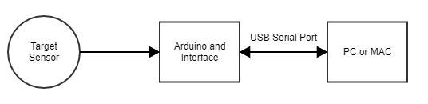

Figure 2-1: General Connection

The data is transferred between the Arduino and PC using a USB serial port. The baud rate shall be set to 115,200

All messages shall be transmitted as a JSON payload between the two computers. See the applicable documents section for an illustration

2.1. Arduino to PC  
Target information, for example impact location is transmitted from the Arduino to the PC.

**2.1.1. Shot Information**

Shots are recorded as

**{"shot": s, "x":xPosition, "y":yPosition, “r”:radius, “a”:angle}**

Where  
shot - Current shot number 1 ...

xPosition - Location of the shot in mm from the centre of the target. Positive to the right

yPosition - Location of the shot in mm from the centre of the target. Positive up

radius - Distance in mm from centre of the target.

angle - Angle in degrees (0-360) from centre of the target. Counter Clockise positive

It is up to the display program in the PC to determine if the shot originates from a pistol or rifle, and hence the score associated with a given distance.

2.2. PC to Arduino

To Be Determined

2.3. Sensor Connector

The sensors are connected to the main board using a 12 pin IDC (0.100” spacing) connector. The pinning of the connector is illustrated in Figure 2-3. Each sensor, North, East, South, West is carried over a separate conductor, and the sensor module is responsible for managing the cable.

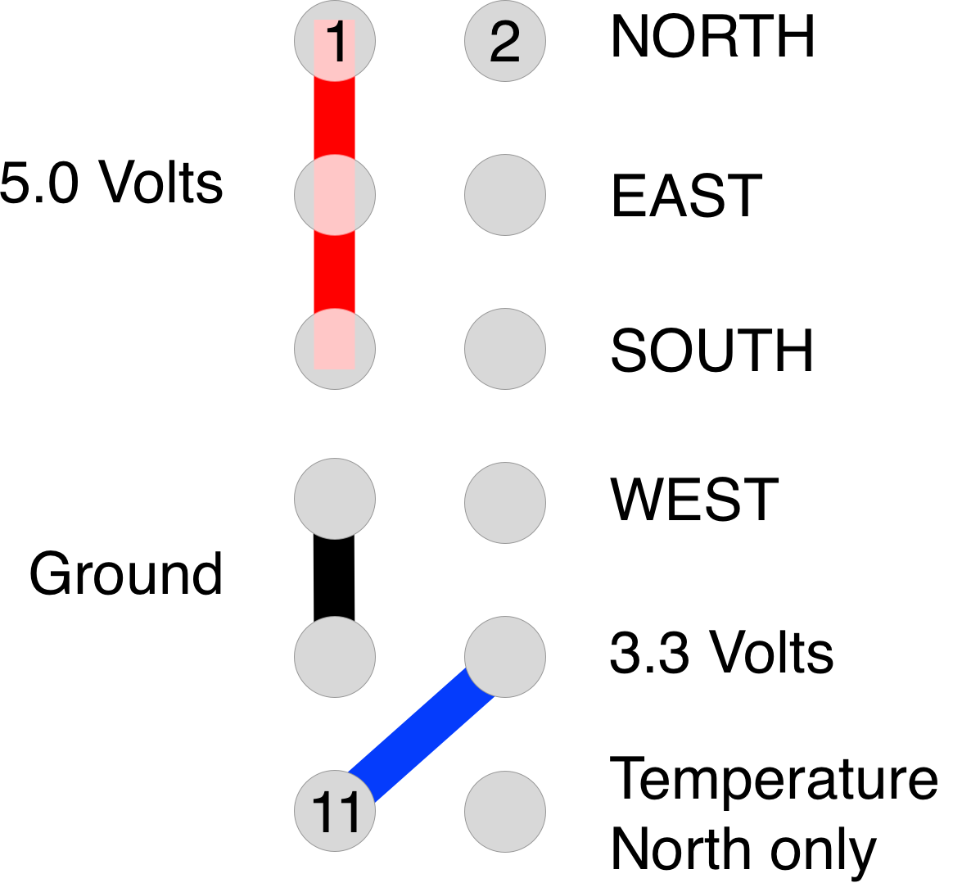

Figure 2-3: Sensor Connector

2.4. Sensor Location

The sensors are located around the edge of the target at a distance of 150mm from each other. The location of the sensors is shown in Figure 2-4.



Figure 2-4: Sensor Mechanical Assembly

The critical dimensions to observe are:

* Edge-to-edge distance of the sensors (150 mm)
  + Errors in this dimension will shift the centre location
* Angular alignment of the sensors
  + Errors in this dimension will rotate the shot group.
* The temperature probe should be located close to one of the sensor modules